**INGLÊS V – BANCO DE DADOS**

Class Didactic Material

Profa. Teresinha de Fátima Nogueira

**Class 1 - Content: Conflict resolution in the workplace**

Objective – dealing with conflict at work.



(from <https://www.istockphoto.com/br/search/2/image-film?phrase=workplace+conflict>)

Problem 1: You are facing some different sorts of conflicts at work. In small groups of 3, choose one of them, discuss it and present your solutions to solve the problem. (2,5 pontos)

**1-Different styles of working:**

Your manager has put you and your colleague together to work on producing a new staff handbook. Unfortunately, your different working styles cause conflict between you. While you prefer group work, they prefer to work by themselves. You like working to a tight deadline, whereas your colleague prefers to get things done ahead of time. You're spending more time arguing about how to write the handbook than writing the document.

**2-Discrimination:**

You find yourself passed over for a promotion again, only this time you know the other candidate was less qualified than yourself. When you ask for feedback, it's vague and indirect. You worry that there's another reason, besides performance, for their decision. You feel uncomfortable and think you ought to raise this with someone.

**3-Experiencing creative differences:**

You're on an architectural team designing a new school building. You're excited to have this opportunity. You're working with another person on the interior design elements, such as the final build's colour schemes and furniture. While you're worried about the overall aesthetic appeal for the students, your partner only seems to care about functionality. You feel like they're dismissing your ideas without even considering them, and it's causing friction between you.

**4-Employee not meeting expectations:**

You're a manager of the payroll staff, and one employee has recently started turning in timesheets late. This problem affects more than just your department's performance, as it means other employees receive their pay checks late. You've also noticed that they're withdrawn from the team and seem more distanced from work. While you're annoyed about their work performance, you're also concerned about their welfare.

**5-Disagreement over a task:**

You're in your weekly team meeting, deciding which marketing strategy to take on your next project. You and your colleague disagree about which is the best route. You think solution one offers the most significant benefits to your client, while your colleague feels solution two mutually benefits both companies. The discussion becomes heated, and you feel frustrated. Try finding a resolution that encompasses both your points.

(adapted from <https://uk.indeed.com/career-advice/career-development/workplace-conflict-examples>)

To help you to solve the problem, you can do the proposed activities below or choose your own way:



(from <https://www.istockphoto.com/br/search/2/image-film?phrase=workplace+conflict>)

1 – Reading and vocabulary: Read this text about conflict resolution in the workplace, and check understanding with your teacher or another student. Take notes if it’s necessary.

**7 tips on how to manage and resolve conflict in the workplace**

(By Allen Cranston, April 27, 2021)

[…]

## ****1. Clarify what is the source of conflict****

The first step in [resolving conflict](https://hr.berkeley.edu/hr-network/central-guide-managing-hr/managing-hr/interaction/conflict/resolving) is clarifying its source. Defining the cause of the conflict will enable you to understand how the issue came to grow in the first place. Additionally, you will be able to get both parties to consent to what the disagreement is. And to do so, you need to discuss the needs which are not being met on both sides of the issues. Also, you need to warranty mutual understanding. Ensure you obtain as much information as possible on each side’s outlook. Continue asking questions until you are confident that all the conflicting parties understand the issue

## 2. Find a safe and private place to talk

Many people often wonder and ask, “What is an approach to solving problems peacefully?” To have a constructive conversation, you need to find an environment that is safe for you to talk to. Such a place also enables you to take the necessary risks for honest communication regarding the issues at hand. So, before trying to resolve any issue, find a safe and private place to talk. Do not choose the office of either party or a location near them. And while at this place, ensure that each party gets enough time to air out their views regarding the matter.

## ****3. Listen actively and let everyone have their say****

After getting both parties to meet in a secure and private place, let each of them have the opportunity to air out their views and perceptions regarding the issue at hand.  Give each party equal time to express their thoughts and concerns without favoring the other. Embrace a positive and assertive approach while in the meeting. If necessary, set ground rules. Taking this approach will encourage both these parties to articulate their thoughts in an open and honest manner as well as comprehend the causes of the conflict and identify solutions.

## ****4. Investigate the situation****

After listening to the concerns of both parties, take time, and investigate the case. Do not prejudge or come up with a final verdict on the basis of what you have. Dig deeper and find out more about the happenings, involved parties, the issues, and how people are feeling. Have an individual and confident conversation with those involved and listen in a keen manner to ensure you comprehend their viewpoints. You can do so by summarizing their statements and replicating them back to them. Also, try finding any underlying conflict sources which may not be evident or noticeable at fast.

## ****5. Determine ways to meet the common goal****

When [managing conflict processes](https://www.hrcloud.com/blog/how-to-resolve-conflict-effectively), you need to have a common objective, which is resolving the issue and ensuring it does not resurface. And to solve any problem, you need to be aware of the different stages of conflict. This will enable you to look for the ideal ways to meet the common goal. After clarifying the source of conflict, talking to both parties, and investigating the situation, you need to sit down with both parties and discuss the common ways you can execute to meet the common goal, which is managing and resolving the matter at hand. Listen, communicate and brainstorm together until you exhaust all options.

## ****6. Agree on the best solution and determine the responsibilities each party has in the resolution****

[Managing and resolving conflict](https://www.hrcloud.com/blog/5-conflicts-at-work-and-how-you-can-resolve-them) leaps model of communication. Employees will find it easy to interact with another as they understand that they have one goal, which is meeting the company’s objectives. So, after investigating the situation and determine ways through which you can resolve the issue, both parties need to develop a conclusion on the best solution for the problem. And to agree on the best, you need to identify the solutions which each party can live with. Find common ground. Afterward, determine the responsibilities each party has in resolving the conflict. Also, it is crucial to use this chance to identify the root cause and ensure this issue will not come about again.

## ****7. Evaluate how things are going and decide preventative strategies for the future****

Never presume that the issue is resolute. [Effective communication](https://www.hrcloud.com/blog/how-effective-communication-improves-employee-trust-and-engagement) ought to dominate in the business. So, ask yourself, “What is the second step of effective communication?” and "What kind of [internal communication](https://www.hrcloud.com/internal-communication-software) is there in the company?" Knowing this will help you ensure that the employees are working together to meet the organizational goals. So, continue keeping an eye on the issue and assess if the solution is effective.  If the issue resurfaces, take necessary action.

In conclusion, conflict is part of our day-to-day lives. You can disagree with your family, friends, or coworkers. But, there are various conflict resolution steps you can embrace to ensure this issue is not manageable. Managing and resolving conflict at work is integral in meeting organizational goals. So, if you have any problems or there are disagreements between your employers, look for ideal ways you can manage this situation.

(from <https://www.hrcloud.com/blog/7-tips-on-how-to-manage-and-resolve-conflict-in-the-workplace>)

2 – Video – watch this video which presents a summary on how to deal with conflict at work and take notes if it is necessary.

<https://www.youtube.com/watch?v=rXiMGT-Ie0M>

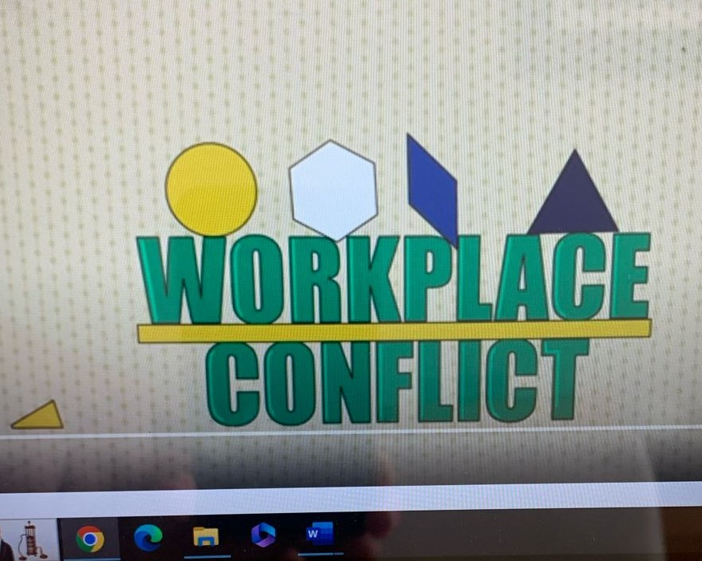

**Class 2 - Content: Conflict resolution in the workplace**

Objective – dealing with conflict at work.



(from <https://www.freepik.com/free-photos-vectors/workplace-conflict>)

3– Speaking: ask and answer these questions:

### 1-Is conflict always negative? Explain

2-What would you consider to be a constructive approach to conflict?

3-What would you consider to be a destructive approach to conflict?

### 4- Do you normally try to look at conflict situation from another point of view? Why? Why not?

5-Are there any times where you had a conflict with a superior? If yes, how did you handle it and resolve it?

6- How do you deal with the differences of opinion when working on a team?

## **7- How do you handle a customer who’s angry?**

8-Tell me about a time that you disagreed with a rule or approach.

9- Tell me about a time you disagreed with a co-worker’s idea on a project you were both working on together. How did you express your opposition and what happened?

10-What would you do if your manager gave you negative feedback on the way you approached a problem?

11- Who is the best conflict resolver you've known?   What did he/she do that was so effective?

12- Who is the worst conflict resolver you've known?   What did he/she do that was destructive?

**Class 3 - Content: Conflict resolution in the workplace**

Objective – dealing with conflict at work.



(from <https://www.freepik.com/free-photos-vectors/workplace-conflict>)

4– Speaking: prepare the oral presentation about conflict resolution suggested in problem 1.

**Class 4 - Content: Conflict resolution in the workplace**

Objective – dealing with conflict at work.

5 – Oral presentation – Presentation of the activity suggested in problem 1. (2,5 pontos)



(from <https://www.freepik.com/free-photos-vectors/student-presentation>)